

**COMSATS University Islamabad**

**Abbottabad, Pakistan**

**Project proposal**

　　Automated Attendance System

**CSC392 Object Oriented Software Engineering**

　　 Submitted on: 27/10/2022

**Group members:**

　　Muhammad Haris Reg# Sp21-bse-019

　　Saad Hussain Reg # Sp21-bse-020

　　Mian Habib Reg# Sp21-bse-042

　Muddassir Ali Reg# SP21-bse-016

　　Huzaifa Sajjad Reg # Sp21-bse-012

　　Maaz Latif Reg # Sp21-bse-050

　　Muzamil khan Reg # Sp21-bse-031

Table of Contents

INTRODUCTION 5

Vision and Business Case 5

Executive summary: 5

Business cases: 6

Use cases 6

Supplementary specifications: 8

Risk management: 8

Chapter 2: 10

Use cases Diagrams 10

Muhammad Haris (SP21-BSE-019) 13

Brief level use cases: 13

Make payment 13

Register student: 13

View student: 14

Update student: 14

Delete student: 14

Huzaifa Sajjad 14

Request for teacher status: 15

Provide teacher status: 15

View teacher: 15

Update teacher: 15

Muddassir Ali ( SP21-BSE-016) 16

sign up 16

sign in 16

View feed back 16

view timetables 16

Muhammad Saad Hussain 16

Maaz khan: 17

Muzamil khan 17

Fully dressed Use cases 18

Muhammad Haris 18

Make payment 18

Register Student 20

View student 23

Update student 25

Delete student 28

Muhammad Saad Hussain (Sp21-bse-020) 30

View Attendance 30

Update Attendance 31

Scan Students 32

Create Timetable 32

count Rooms 33

Huzaifa Sajjad (Sp21-bse-012) 34

Requests for teacher status 34

Provide teacher status 36

View teacher 37

update teacher 39

Muddassir Ali ( SP21-BSE-016) 41

Sign up 41

sign in 42

View feed back 44

View Timetable 45

Maaz Khan 46

Generate Feedback 46

View Feedback 47

Chapter 3 48

Domain model 48

Chapter 4 49

System Sequence Diagrams 49

Muhammad Haris (Sp21-bse-019) 49

Register Student 49

Make payment 50

Teacher login 50

View student 51

Delete student 53

Sign in 54

Sign up 55

View timetable 56

View feedback 57

Chapter : 5 Operation contracts 58

Muhammad Haris (sp21-bse-019) 58

Make Payment: 58

Student Registration: 58

Teacher Login: 59

Delete Student: 59

View Student: 59

Teacher login 60

Muddassir Ali (sp21-bse-016) 60

Sign in 60

Sign up 61

View timetable 61

View feedback 62

Chapter: 6 63

package diagram 63

## INTRODUCTION

　　We are designing automatic attendance system using face detection. The system needs or required video recording device. It detects the face and mark attendance accordingly. This system will prevent unnecessary wastage of time that is usually wasted in form of class roll calls. In the Automated Attendance System, the process flow is initiated by being able to detect the facial features from a camera or a picture stored in a memory.

## Vision and Business Case

　　The system will automate the attendance system of all educational institutes.

　　It will be useful in preventing proxy attendance.

　　It will save time up to at least 5 minutes per class.

　　It is the most efficient way of marking attendance.

　　There is no margin of mistake as there is in manual system.

## Executive summary:

　　it is an attendance system fully based on artificial intelligence. The system will scan students and compare them with the saved data in data base. It will be very helpful in reduction of attendance time and also false attendance. All a teacher has to do is to scan student faces and the rest is done by the system. It will automate the attendance system with more efficiency and reliability.

***high-level goals and constraints***

|  |  |  |  |
| --- | --- | --- | --- |
| High-level Goals | Priority | Problems and Concerns | Current Solutions |
| Fast, user friendly, reliable, efficient,  　　Automated Attendance System | High | False attendance  　　Time consuming  　　Less management  　　No feedback process. | Attendance should be automated. |

## Business cases:

　　Student management:

　　 The system will manage all affairs of students from registration till deletion.

　　Teacher management:

　　 The system will manage all affairs of teachers their registration, updating their status, and all relative businesses of teachers.

　　Attendance management:

　　 This is the main concern of our system the system will handle the attendance with artificial intelligence, it will scan students, compare their face structure with the stored ones in data base and generate attendance report.

　　Timetable management:

　　 The system will also automate the time table creation, it will automatically generate timetable and also manage it.

　　Feedback management:

　　 The system will generate report progress and also the concerned teacher’s review against each student and sent it to guardians so that they would also be able to see their children progress.

　　There will also be feedback of students generated against the concerned teacher.

## Use cases

1. Fee payment:

　　Student will pay the fee which can be through various means.

1. Student registration:

　　Student will generate a registration request and after verification student will be registered.

1. Student login:

　　Student will be provided with login id and password through which he/she could use the functionalities of the system.

1. Update student:

　　Student status will be updated through this system.

1. View student:

　　Student status will be viewed by admin and teacher and the student itself.

1. Delete student:

　　Student data will be deleted under several conditions.

1. Search student:

　　A particular student will be searched through this system by admin and teacher.

1. Teacher registration:

　　Teacher will be registered upon the request that the teacher make to be registered as a teacher.

1. View teacher:

　　Teacher will be viewed through this system by admin any time he/she desires.

1. Update teacher:

　　The system will be able to update status of any teacher.

1. Delete teacher:

　　Teachers data could be deleted through this system any time the admin desires but under some proper criteria.

1. Search teacher:

　　Admin can search teacher any time.

1. Manage timetable:

　　The system will be able to generate time table by selecting the available room, teachers and students.

1. View timetable:

　　Timetable will be viewable to teacher, admin and students and through timetable students will be able to view their concerned teacher.

1. Mark attendance:

　　The system will mark attendance by scanning student faces and comparing them against the saved ones in database.

1. View attendance:

　　Attendance will be visible to teacher, students and admin.

1. Update attendance:

　　Teacher and admin will be able to update the attendance under some predefined criteria.

1. Notification:

　　The system will be able to generate notification of attendance and other activities of students and send it to admin and student’s guardians.

1. Feedback:

　　Teacher will provide feedback against student and vice versa and will be visible to the admin and student’s guardian.

1. Log out:

　　The system will also provide the functionality of logging out of their accounts from the system to teachers and admin.

## Supplementary specifications:

* Class time will be saved.
* Efficient and fast attendance will be possible.

## Risk management:

　　Reducing class time: Class time will be reduced by the system.

　　Eradicating false attendance: There will be no margin of false attendance.

　　Feedback system: Guardians will also be involved in the system and they will get the progress report of their children.

## Chapter 2:

## Use cases Diagrams

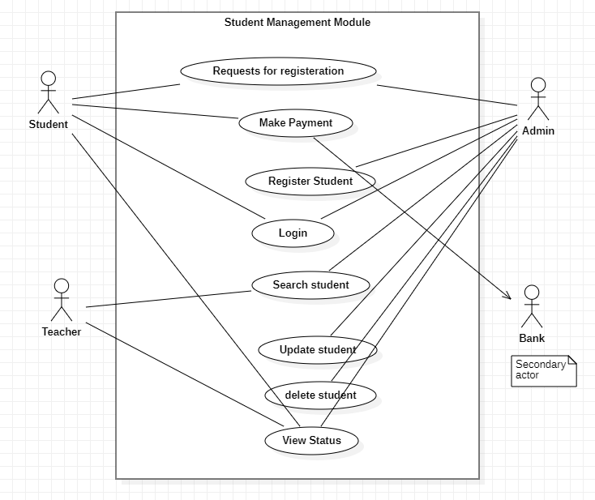

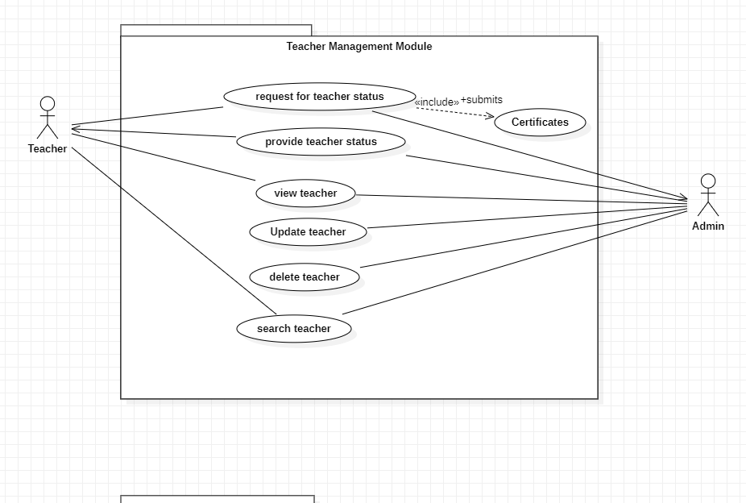

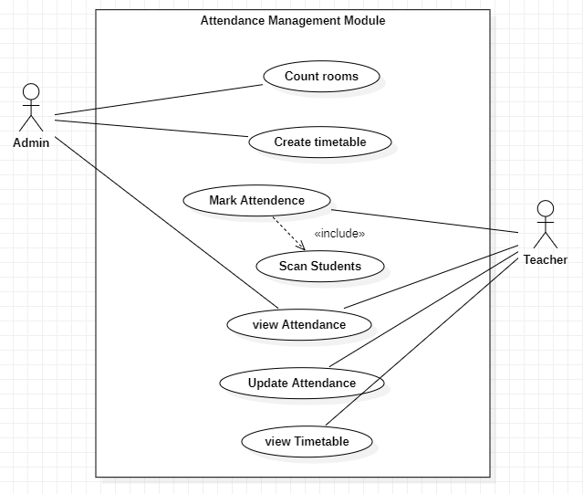

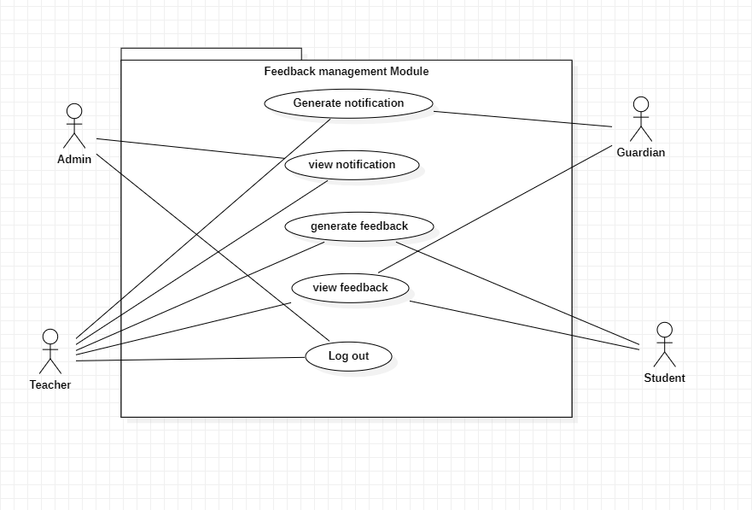

**Muhammad Haris (SP21-BSE-019)**

## Brief level use cases:

　　Assigned Use cases:

　　　　Use case uc1

Make payment:

　　Student opens payment module. Student is asked to choose payment method. Student chooses payment method. Student’s payment is verified from respective bank. System then ask student to confirm its payment. Student confirms its payment. System is notified about student’s payment. System then show list of courses to student.

　　Use case uc 2

Register student:

　　Student requests for registering a course. Registration form appears to student. Student submits the registration form. The form is checked against some predefined standards. The system shows a list of courses to the student. Student selects courses (credit hours no less than 12 not more than 21). Student is registered in his/her desired course. Relevant student data is sent to teacher.

　　Use case uc 3

View student:

　　Teacher/ admin wants to view student’s records. The system ask teacher to enter email and password. Teacher enter email and password. System verify them from data base. Access is granted to teacher. Teacher searches student by registration number. System finds student’s in data base. Student’s records are shown to the teacher/admin.

　　Use case uc 4

Update student:

　　Student requests for updating of his/her status. Admin process his/her request against some standard criteria. Student record is updated.

　　Use case uc 5

Delete student:

　　Student passed the course and do not want to repeat it. Student log in to his account and file a request for removing his data. Student’s request is processed. Admin remove the student from the student course list.

## Huzaifa Sajjad

　　Reg # Sp21-bse-012

**Use Cases:**

**Brief Use Case**

Request for teacher status:

　　The system ask for the teacher status. When the teacher submit the document the Admin will check the document if the teacher are eligible so the system will response verify. Teacher not submit complete document the system will response submit full document. Teacher is not eligible so the system will response not verify.

　Provide teacher status:

First the Teacher submits request for registered. Than the System forward teachers request to admin. Admin process the request against some predefined standards. Teacher is asked to demonstrate in front of relevant teachers. Teacher passes demonstration. Teacher status is granted to him/her

### View teacher:

Update teacher:

　　When Admin logs in to the system by his/her account. In the system Admin searches teacher by his/her id. System looks teacher’s id from data base. System fetches teacher’s data form data base display on system. Teacher data is showed to admin

　　Teacher met the criteria for his/her status to be updated. Teacher requests admin to update its status. Admin process its data. Teacher status is updated.

## 

## Muddassir Ali ( SP21-BSE-016)

sign up

　　 the use case begins when new users (admin, student, teacher) has to make account in system. With making account no one can access the system.

sign in

　　 Users have already account user can login with your own account for example admin login with admin account and teacher login with teacher account and student login with student account.

　　Without sign no one can access the system

View feed back

In this use case teacher wants feedback from students’ parent when student absent teacher send the SMS to the parent your son is absent. Teacher wants feedback from student parent to the result.

view timetables

　　 In this use case student view the timetable and teacher view table to check class timing and slot

## Muhammad Saad Hussain

**Reg no: Sp21-bse-020**

**Use Cases:**

1. View Attendance
2. Update Attendance
3. Scan Student
4. Search Available Students
5. Create Time Table
6. Search Available Rooms
7. Search Available Slots

## Maaz khan:

　　Use cases

　　Generate Feedback

　　View feedback

## Muzamil khan

　　Use cases

　　Notify Admin

　　Notify guardian

Fully dressed Use cases

## Muhammad Haris

**Use Case UC 1**

Make payment

　　Level:

　　 Student, admin, accounts goal

　　Scope:

　　 Automated Attendance System.

　　 Primary actor:

　　 Student

　　Stakeholders and interests:

　　 Admin:

　　 Wants student pay their fee on time so they could proceed with registration process.

　　Student:

　　 Wants to clear their fee so that student should be able to register themselves.

　　Preconditions:

　　 Student is eligible for the courses.

　　 Student already submitted application for registration.

　　Post condition:

　　 Student payment is cleared.

　　 Student is now able to register him/herself.

　　Main success scenario:

1. Student opens payment module.
2. Student is asked to choose payment method.
3. Student chooses payment method.
4. Student’s payment is verified from respective bank.
5. System then ask student to confirm its payment.
6. Student confirms its payment.
7. System is notified about student’s payment.
8. System then show list of courses to student.

　　Extensions:

　　 Student chooses payment by card and the card the balance is less than fee.

　　Alternative flow:

1. Student is asked to add money to its card.
2. Student adds money to its card.
3. Student again proceeds with payment.
4. Courses list is shown to student.

　　Special requirements:

　　 Student should have a valid bank account.

　　Technology:

　　 Computer system, internet connection.

　　Frequency of occurrence:

　　 Student time every year.

　　Miscellaneous:

　　 Card session is expired.

　　 Bank server is down.

　　Screen shot:

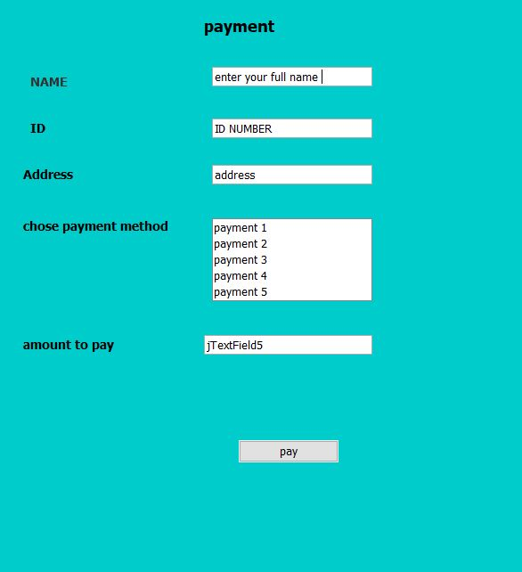

**Use case UC 2**

Register Student

　　Level:

　　 Student goal

　　Scope:

　　 Attendance through face detection.

　　Primary Actors:

　　 Student, Admin

　　Stakeholders:

　　 Student: wants to be enrolled in his/her desired course.

　　Teacher:

　　 Wants the list of students he/she will teach.

　　Parent:

　　 Wants detail of his/her child study progress starting with registration.

　　Admin:

　　 Wants to know how many students enrolled in which course.

　　Preconditions:

　　 Student should be eligible to enroll the course.

　　Post condition:

　　 Student is enrolled in course.

　　Main success scenario:

1. Student requests for registering a course.
2. Registration form appears to student.
3. Student submits the registration form.
4. The form is checked against some predefined standards.
5. The system shows a list of courses to the student.
6. Student selects courses (credit hours no less than 12 not more than 21).
7. Student is registered in his/her desired course.
8. Relevant student data is sent to teacher.

　　Extensions:

　　 Student did not pass all pre requisites of subject to study.

　　Alternative flow:

1. Student first pass the pre-requistes and then register the course.
2. Teacher is arranged for the course, there should be at least 10 students requesting for course registration.
3. Student waits for if anyone withdrawal the course or the student enroll the course with other sections.

　　Special requirements:

1. Course is offered.
2. Concerned teacher is available.
3. Student is eligible for course.
4. Student cleared his/her fee.
5. There are at least 10 student requested to register a course.

　　Technologies:

　　 Computer, internet connection.

　　Frequency of occurrence:

　　 Can occur frequently for one week in start of session.

　　Open issues:

　　 Did not pass pre-requisites for a subject.

　　Screen shot:

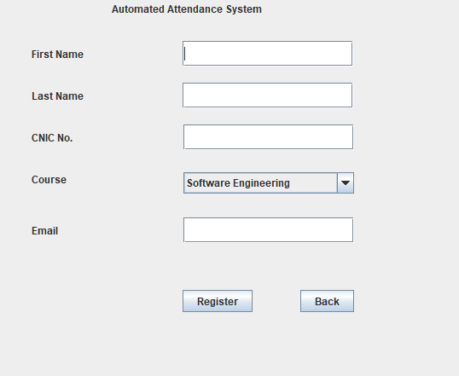

**Use case UC 3**

View student

　　Scope:

　　 Attendance through face detection.

　　Level:

　　 Admin goal, teacher goal

　　Primary actor:

　　 Admin, teacher.

　　Stakeholder and interests:

　　Admin:

　　 Wants to view student’s overall records.

　　Teacher:

　　 Wants to view student’s relevant records.

　　Preconditions:

　　 Student is enrolled in at least one course.

　　Post conditions:

　　 Student’s record is shown to admin or teacher.

　　Main success scenario:

1. Teacher/ admin wants to view student’s records.
2. The system ask teacher to enter email and password.
3. Teacher enter email and password.
4. System verify them from data base.
5. Access is granted to teacher.
6. Teacher searches student by registration number.
7. System finds student’s in data base.
8. Student’s records are shown to the teacher/admin.

　　Extensions and Alternative flow:

　　 Teacher

　　Special requirements:

1. Student is registered in course with concerned teacher.

　　Technology:

　　 Computer, internet

　　Frequency of occurrence:

　　 Can occur in a week.

　　Miscellaneous:

　　 Student is not registered with concerned teacher.

　　Screen shot:

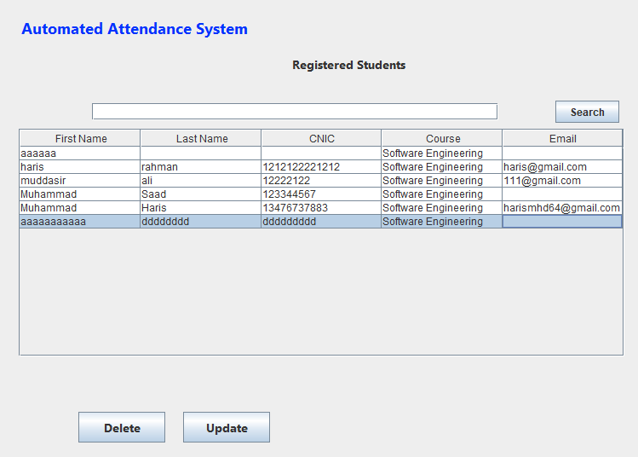

**Use case UC 4**

Update student

　　Level:

　　 Admin goal, student goal

　　Scope:

　　 Attendance through face detection.

　　Primary actors:

　　 Student, Admin

　　Stakeholders and interests:

　　 Student:

　　wants to update his/her status one to another subject i.e. promotion.

　　Admin:

　　 Wants to update the students so that the admin should know how much students passed/failed a particular course and how much new students enrolled in which courses.

　　Teacher:

　　 Wants the updated list of students against his/her course.

　　Preconditions:

1. Student passed the course and want to register the next course.
2. Student’s fee is clear.

　　Post condition:

　　 Student record is updated.

　　Main success scenario:

1. Student requests for updating of his/her status.
2. Admin process his/her request against some standard criteria.
3. Student record is updated.

　　Extension and alternative flow:

1. Student passed a subject but wants to take a pause.

* Admin will place the student in freeze status.

1. Student is graduated so the student record will be placed in graduated students and deleted from enrolled student list.

　　Special requirements:

　　 Student should pass/fail a course and want to leave or be promoted.

　　Technology:

　　Computer, internet.

　　Frequency of occurrence:

　　 Can be repeated several times after every exam.

　　Miscellaneous

　　Screen shot:

**Use Case UC 5**

Delete student

　　Level:

　　 Admin goal.

　　Scope:

　　 Attendance through face detection.

　　Primary actor:

　　 Admin

　　Stakeholders and interests:

　　 Admin:

　　 Wants to remove students passed or failed a course.

　　Teacher:

　　 Wants to have a new list of students and remove the older ones.

　　Student:

　　 Wants to be removed from the courses he/she passed.

　　Preconditions:

　　 Student passed the course or failed and do not want to continue with the course.

　　Post conditions:

　　 Students is removed from the course.

　　Main success scenario:

1. Student passed the course and do not want to repeat it.
2. Student log in to his account and file a request for removing his data.
3. Student’s request is processed.
4. Admin remove the student from the student course list.

　　Special requirements:

　　 Student do not want to continue with the course.

　　Technology:

　　 Computer, internet

　　Frequency of use:

　　 Can occur multiple times after examinations.

　　Open issues:

　　 Electricity shortfall, internet connection not available etc.

## Muhammad Saad Hussain **(Sp21-bse-020)**

**Use Cases:**

View Attendance

|  |  |
| --- | --- |
| **Use Case Section** | **Comment** |
| Use Case Name | View Attendance |
| Scope | Automatic attendance system |
| Level | Main Function |
| Primary Actor | 1: Teacher  　　2: Student  　　3: Parents |
| Stake holders and interests | 1. Student (check attendance) 2. Teacher (Mark attendance)   　　3: Parents (Mark Attendance) |
| Pre conditions | after the successful face detection, Attendance will be marked and then view them. |
| Success guarantee | View the attendance sheet after marking. |
| Main Success Scenario | 1: Parent must excess the son attendance by login the portal.  　　2: student can see his own attendance.  　　3: Teacher can mark /unmark the student in the attendance sheet and also see them. |
| Extensions |  |
| Special Requirements | 1: It should be reliable.  　　2: it has high performance and secure database.  　　3: User friendly: user can easily understand and handle in first use. |
| Technology and Data Variations List | Student can search university portal while logged in using his password and username given to him. |
| Frequency of Occurrences | 24/7 hours. |
| Miscellaneous | 1: Attendance sheet does not be shown. Because of internet issues and server down. |

　Update Attendance

|  |  |
| --- | --- |
| **Use Case Section** | **Comment** |
| Use Case Name | Update Attendance |
| Scope | Automatic attendance system |
| Level | Main Function |
| Primary Actor | Teacher |
| Stake holders and interests | Teacher (only teacher can update) |
| Preconditions | After successful mark the attendance, we can also update the attendance within 3 days. |
| Success guarantee | Update the attendance sheet after marking. |
| Main Success Scenario | Teacher has rights to update the wrong attendance. |
| Extensions | After 3 days later, attendance will not be update.  　　Teacher is not correct the wrong attendance. |
| Special Requirements | 1: It should be reliable.  　　2: it has high performance and secure database.  　　3: User friendly: user can easily understand and handle in first use. |
| Technology and Data Variations List | Student can search university portal while logged in using his password and username given to him. |
| Frequency of Occurrences | 3 days. |
| Miscellaneous | 1: update Attendance does not be generate or correct Because of internet issues and server down |

### Scan Students

|  |  |
| --- | --- |
| **Use Case Section** | **Comment** |
| Use Case Name | Scan Student |
| Scope | Automatic attendance system |
| Level | Main Function |
| Primary Actor | Admin |
| Stake holders and interests | Admin  　　Teacher |
| Preconditions | First register himself then login it and then open face sensor. |
| Success guarantee | Face will be detected successfully. |
| Main Success Scenario | after the successful face detection, Attendance will be marked. |
| Extensions | Sometime face out of range. |
| Special Requirements | 1: It should be reliable.  　　2: it has high performance and secure database.  　　3: User friendly: user can easily understand and handle in first use. |
| Technology and Data Variations List | Student can search university portal while logged in using his password and username given to him. |
| Frequency of Occurrences | Only a specific class time |
| Miscellaneous | Because of darkness face will not detected.  　　Internet issues.  　　System should be hanged. |

### Create Timetable

|  |  |
| --- | --- |
| **Use Case Section** | **Comment** |
| Use Case Name | Create Time Table |
| Scope | Automatic attendance system |
| Level | Main Function |
| Primary Actor | admin |
| Stake holders and interests | Teacher  　　 Admin |
| Preconditions | After successfully scan face, we create timetable for to present and absent the students. |
| Success guarantee | Daily classes attended or unattended by students through create table. |
| Main Success Scenario | To see how much classes attended or not. |
| Extensions |  |
| Special Requirements | 1: It should be reliable.  　　2: it has high performance and secure database.  　　3: User friendly: user can easily understand and handle in first use. |
| Technology and Data Variations List | Student can search university portal while logged in using his password and username given to him.  　　Sensor can scan in the face of student and scan him. |
| Frequency of Occurrences | Specific time (depend on class time) |
| Miscellaneous | Server down  　　Not scan face because of darkness  　　Errors |

### count Rooms

|  |  |
| --- | --- |
| **Use Case Section** | **Comment** |
| Use Case Name | Search Available Rooms |
| Scope | Automatic attendance system |
| Level | Main Function |
| Primary Actor | Admin |
| Stake holders and interests | Admin |
| Preconditions | After successful login the system, before scan of face search available rooms for class. |
| Success guarantee | Already available room |
| Main Success Scenario | Room available for lecture |
| Extensions | Something scan face but not check rooms for lecture so many times not be available |
| Special Requirements | Good performance and minimum time consume |
| Technology and Data Variations List | Student can search university portal while logged in using his password and username given to him. |
| Frequency of Occurrences | Specific time (before lecture start) |
| Miscellaneous | 1: available room does not be generate or correct Because of internet issues and server down |

## Huzaifa Sajjad (Sp21-bse-012)

### Requests for teacher status

|  |  |
| --- | --- |
| Use Case Name | Request for teacher status |
| Scope | teacher status verification |
| Level | Teacher Goal |
| Primary Actor | Teacher |
| Stake holders and interests | teacher |
| Pre conditions | When the teacher first time use this system  　　He will upload has education documents  　　Than admin will check the documents if the document clear than admin will allow the teacher and allow access |
| Success guarantee | After successful completion of the use case the teacher will be allow for every things which belongs to teacher in the system |
| Main Success Scenario | 1. Teacher open the System 2. The system request for documents upload 3. The system will responses eligible are not 4. If the teacher is upload eligible document the system will verify it 5. Allow the teacher to access the system |
| Extensions |  |
| Special Requirements | * The system will not accept irrelevant document * The upload document should be clear and net |
| Technology and Data Variations List |  |
| Frequency of Occurrences | Could be nearly continuous. |
| Miscellaneous |  |

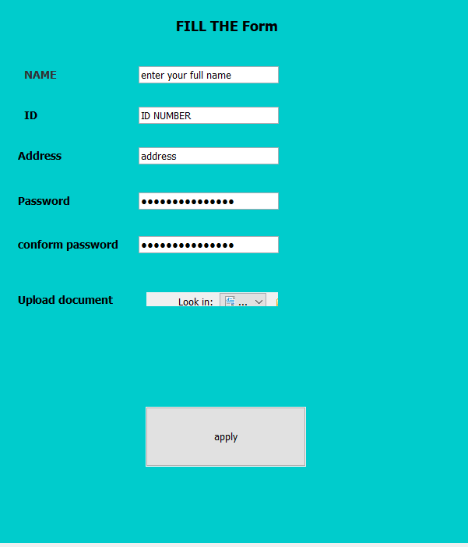

### Provide teacher status

|  |  |
| --- | --- |
| Use Case Name | Provide teacher status |
| Scope | Automated attendance system |
| Level | Admin –goal |
| Primary Actor | Admin |
| Stake holders and interests | If the Admin wants to check teacher  　　status |
| Pre conditions | 1.teacher should be already register |
| Success guarantee | Teacher status is showed to Admin |
| Main Success Scenario | 1. Teacher submits request for registered. 2. System forward teachers   　　 request to admin   1. Admin process the request against some predefined standards. 2. Teacher is asked to demonstrate in front of relevant teachers. 3. Teacher passes demonstration. 4. Teacher status is granted to him/her |
| Extensions | Teacher did not pass demonstration |
| Alternative flow | 1. Teacher is sent to teaching school for training. 2. He/she completes the training period 3. After completing training teacher is provided teacher status. |
| Special Requirements | Teacher should have specialization in the subject he/she is teaching |
| Technology and Data Variations List | Computer system, internet connection. |
| Frequency of Occurrences | Can occur when hiring a teacher. |
| Miscellaneous | . system failure, internet issues, data base crashing |

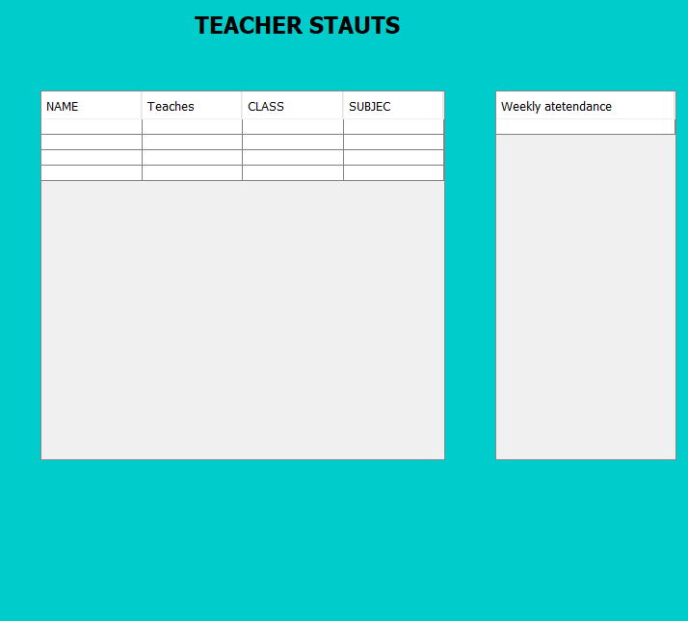

### View teacher

|  |  |
| --- | --- |
| Use Case Name | View teacher |
| Scope | Automated attendance system |
| Level | Admin –goal |
| Primary Actor | Admin |
| Stake holders and interests | 1. Admin wants to check teacher status |
| Pre conditions | teacher should already be registered in system |
| Success guarantee | Teacher status is showed to admin |
| Main Success Scenario | 1. Admin logs in to the system by his/her account. 2. Admin searches teacher by his/her id. 3. System looks teacher’s id in data base. 4. System fitches teachers data form data base 5. Teacher data is showed to admin |
| Extensions | Teacher is not registered on the system. |
| Alternative flow | Teacher is registered on the system.  　　Teacher’s data is now available to admin. |
| Special Requirements | Teacher is registered on the system. |
| Technology and Data Variations List | Computer system, internet connection, data base. |
| Frequency of Occurrences | Can occur daily. |
| Miscellaneous | system failure, internet issues, data base crashing |

### update teacher

|  |  |
| --- | --- |
| Use Case Name | update teacher |
| Scope | Automated attendance system |
| Level | Admin –goal |
| Primary Actor | Admin |
| Stake holders and interests | Admin wants to update teacher status.  　　Teacher wants to be updated to higher status. |
| Pre conditions | Teacher should meets the criteria for higher rank. |
| Success guarantee | Teacher status is updated |
| Main Success Scenario | 1. Teacher met the criteria for his/her status to be updated. 2. Teacher requests admin to update its status. 3. Admin process its data. 4. Teacher status is updated. |
| Extensions | Teacher did not meet the criteria to be updated. |
| Alternative flow | Teacher is advised to fulfill the criteria. |
| Special Requirements | Teacher is registered on the system. |
| Technology and Data Variations List | Computer system, internet connection, data base. |
| Frequency of Occurrences | Once in a year. |
| Miscellaneous | system failure, internet issues, data base crashing |

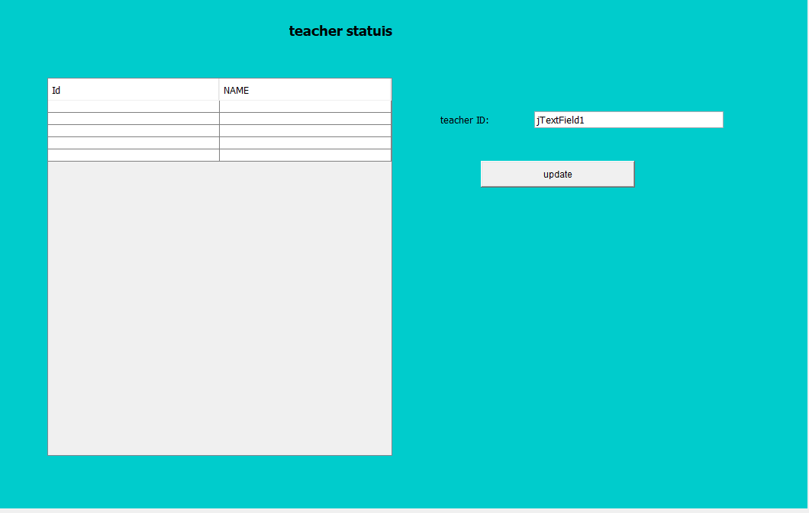

## Muddassir Ali ( SP21-BSE-016)

Sign up

|  |  |
| --- | --- |
| Use Case Name | Sign up |
| Scope | Automatic attendance System face detection app |
| Level | Main function |
| Primary Actor | * Admin * Student * teacher |
| Stake holders and interests | * Admin * Student * teacher |
| Preconditions | User must have to visit the website or app and proper internet |
| Success guarantee | Users (Student, teacher, admin) enter your own registration and password and retype password will be same so account has been created and store in data base. |
| Main Success Scenario | Admin verify the email and verify code which is send by the user email.  　　Users click on register button account has been created. |
| Extensions | Your password is wrong or email |
| Special Requirements | 1: It should be reliable.  　　2: it has high performance and secure database.  　　3: User friendly: user can easily understand and handle in first use. |
| Technology and Data Variations List | Computer internet |
| Frequency of Occurrences | 24/7 |
| Miscellaneous | Admin cannot verify code user cannot register.  　　Email does not send to admin.  　　Internet issue.  　　Type and conform password do not match |

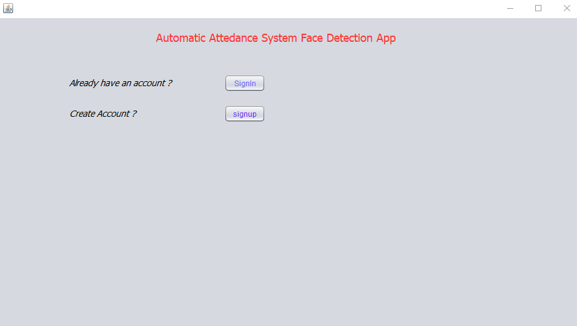

### sign in

|  |  |
| --- | --- |
| Use Case Name | Login |
| Scope | Automatic attendance System face detection app |
| Level | Main function |
| Primary Actor | * Admin * Student * Teacher |
| Stake holders and interests | * Admin * Student * Teacher |
| Preconditions | User must have a valid account and enter a correct id and password. |
| Success guarantee | After the use case end and successful login and verification is complete. And interface will show in screen. |
| Main Success Scenario | System automatically verifies the username and password it is match in data base or not. |
| Extensions | Your password or email is wrong |
| Special Requirements | 1: It should be reliable.  　　2: it has high performance and secure database.  　　3: User friendly: user can easily understand and handle in first use. |
| Technology and Data Variations List | Computer Internet |
| Frequency of Occurrences | 24/7 |
| Miscellaneous | User (student, admin, teacher) enter a wrong email and password and they does not excess the website. |

　　When you click on sign in button

### View feed back

|  |  |
| --- | --- |
| Use Case Name | View feedback |
| Scope | Automatic attendance System face detection app |
| Level | Main function |
| Primary Actor | Teacher  　　Parents |
| Stake holders and interests | Parents  　　Teacher |
| Preconditions | After the successful mark attendance teacher can generate feedback those who not present |
| Success guarantee | Parent can know about their children report. |
| Main Success Scenario | When the student is absent, the feedback of their absentees will be generated to their parents. |
| Extensions | Data base problems |
| Special Requirements | It should be safe and reliable  　　Good performance speed. |
| Technology and Data Variations List | Computer Internet |
| Frequency of Occurrences | 24/7 |
| Miscellaneous | User (student, admin, teacher) enter a wrong email and password and they does not excess the website. |

### View Timetable

|  |  |
| --- | --- |
| Use Case Name | View timetable |
| Scope | Automatic attendance System face detection app |
| Level | Main function |
| Primary Actor | Teacher  　　Student |
| Stake holders and interests | Student (Wants to view timetable to know about time and room number of his/her class.)  　　Teacher (Wants to view timetable to about the class whom he/she will teach and the time of class). |
| Preconditions | Each must be logged in to their account. |
| Success guarantee | Timetable is shown to teacher or student. |
| Main Success Scenario | Teacher requests log in to the system  　　System processes the request and allow access to teacher.  　　Teacher searches the timetable  　　Timetable is shown on its screen. |
| Extensions | No internet |
| Special Requirements | It should be safe and reliable  　　Good performance speed. |
| Technology and Data Variations List | Through login we will see feedbacks |
| Frequency of Occurrences | Depend upon changing the timetable. |
| Miscellaneous | If rooms are not available.  　　If time is not set timetable clash. |

## Maaz Khan

Generate Feedback

　　Scope:

　　Attendance through face detection

　　Level:

　　Organizational goal

　　Primary Actor:

　　Admin, HOD, MD

　　Organization Head:

　　 CEO

　　(Wants feedback from the customer on their product)

　　Pre Conditions:

　　Generating feedback from the student regarding their studies

　　Post Conditions:

　　Generating of feedback is easy for the ceo or manager to understand

### View Feedback

　　Scope:

　　Attendance through face detection

　　Level:

　　Organizational Goal

　　Primary Actor:

　　Admin, Manager

　　Head:

　　CEO

　　Preconditions:

　　Viewing feedback from the customers once they use the product

　　Post Conditions:

　　Viewing feedback in the end if something is necessary for adding ,

　　they have to update in new version.

　　Technology:

　　Modern Science , Internet

# Chapter 3

## Domain model

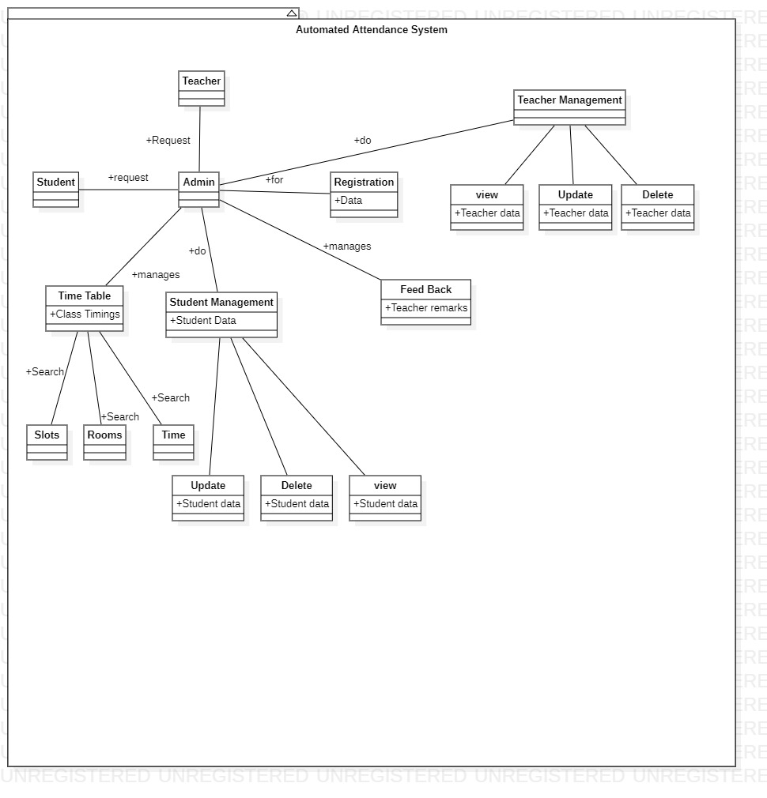

# Chapter 4

# System Sequence Diagrams

## Muhammad Haris (Sp21-bse-019)

### Register Student

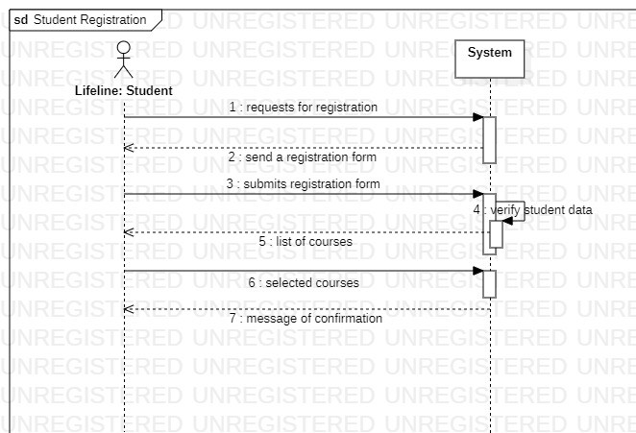

### Make payment

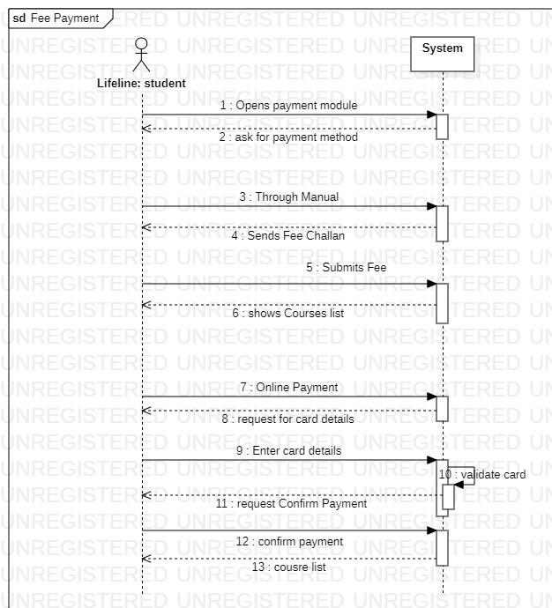

### Teacher login

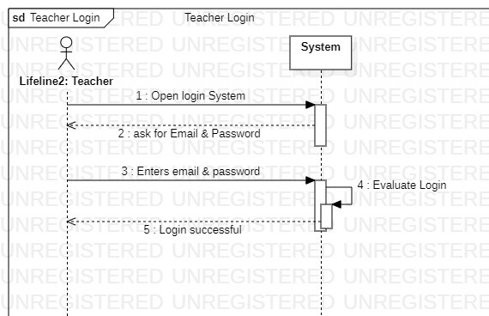

### View student

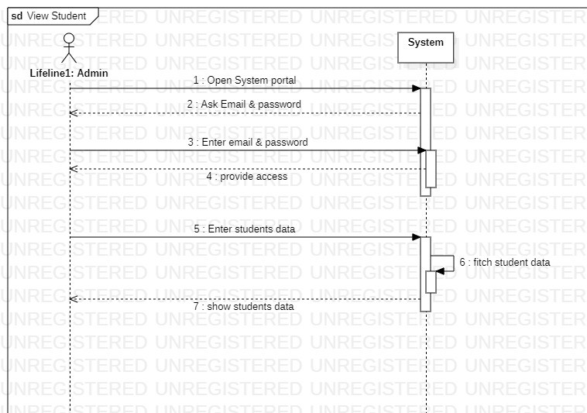

### Delete student

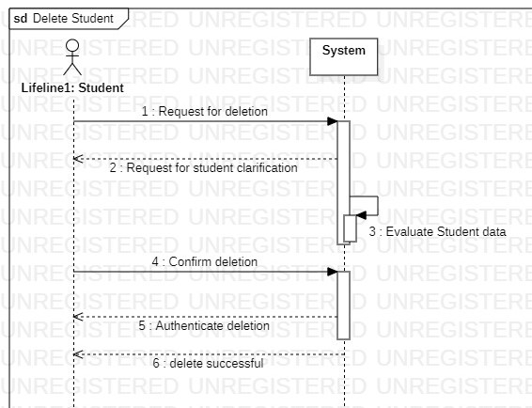

　　Muddassir Ali　(Sp21-bse-016)

Sign in

### Sign up

View timetable

View feedback

## Chapter : 5 Operation contracts

## Muhammad Haris (sp21-bse-019)

### Make Payment:

**Operation:**  enter_data(id: string, card_no: int)

**Cross reference:** Make payment

**Preconditions:** student is registered in the system.

**Post conditions:** Do payment was initiated by student.

The system asked student to enter it’s id and card number.

The student entered card number.

System validated the card number .

After validation the student was asked to confirm the payment.

On confirming payment the student was provided with the course list.

### Student Registration:

**Operation:** enter data (name: string, id: string)

**Cross reference:** student registration

**Precondition:** the student cleared pre-requistes and payment.

**Post conditions:** student initiated student registration interface.

The student was asked to provide its name and id.

The student provided name and id.

After verification of student provided data the system authorized student to register courses.

### Teacher Login:

Operation: enter Data (Name: string, password: string)

Cross reference: Teacher Login.

Preconditions: teacher is already registered in system.

Post conditions: instance was created by teacher.

The system asked about name and password.

Teacher entered name and password.

After verification of name and password the is authorized in the system.

### Delete Student:

**Operation:**  Enter data(Enter student-id: string, delete student-id: string)

**Cross reference:** Delete student

**Precondition:** Student passed the course

**Post conditions:** instance was created by admin.

Student passed the course or graduated.

admin removed the student id I.e. Student record is deleted.

### View Student:

**Operation:** Enter data(Enter student-id: string)

**Cross reference:** view student

**Precondition:** student is already registered in system.

**Post conditions:** instance was created by admin

Admin logged in to the system and entered student-id

The system fetched student data from data base

Student data was showed to admin.

### Teacher login

**Operation:** Enter data(Enter teacher-id: string, password: string)

Cross reference: Teacher login

Precondition: Teacher is already registered in system.

Post conditions: instance was created by teacher.

Teacher entered it’s login-id and password.

The system compared entered data with the data in data base.

Teacher was provided access to the teacher interface.

## Muddassir Ali (sp21-bse-016)

### Sign in

|  |  |
| --- | --- |
| Contract id: 01 | |
| Operation | enter Data (Name: string, password: string) |
| Cross reference | Sign in |
| precondition | User must have to authorize the screen |
| Post conditions | Instance was created  　　System was associated with the data base and match data. |

### Sign up

|  |  |
| --- | --- |
| Contract id: 02 | |
| Operation | enter info (Name : string , email Address : string , password : string) |
| Cross reference | Sign up |
| precondition | User must have to authorize the screen |
| Post Condition | Instance was created  　　Data base was modified, and new user record was saved in data base  　　System was associated with the data base and new object was created. |

### View timetable

|  |  |
| --- | --- |
| Contract id: 03 | |
| Operation | Enter id (teacher id : string , student id , string) |
| Cross reference | view timetable |
| precondition | User must have to authorize the screen |
| Post Condition | View timetable was initiated by the user (could be student, teacher, or admin).  　　New Object are created by the student and teacher. |

### View feedback

|  |  |
| --- | --- |
| Contract id: 04 | |
| Operation | **enter Id** (teacher id : string , parented : string) |
| Cross reference | View feedback |
| precondition | User must have to authorize the screen |
| Post Condition | New object was created.  　　View Feedback was initiated by the user (could be student, teacher, or parent). |

# Chapter: 6

# package diagram

